Point of Sale System
Version 1.0

User Manual

Introduction
The Point of Sale is an online application that will help in keeping records of your orders easily.

The system will allow registered users to easily do the following:
- Add or Remove new vehicles
- Edit details of vehicles (price, description, options etc)
- Create new users to manage the content and grant all or specific permissions
- Create new Make or Model
- Add new transmission type
- Create new quotation for a customer
- Convert a quotation to sale in just 1 click
- Receive multiple payments for a sale
- Manage the status of the vehicle [Available, Coming Soon, Reserved, Sold]

Users
Who is a user? Any person who uses the application is a user and must be created by an administrator. When a new user is added, no permissions is granted by default and must be granted manually as needed. There are two different user levels: normal and admin.

Sign In
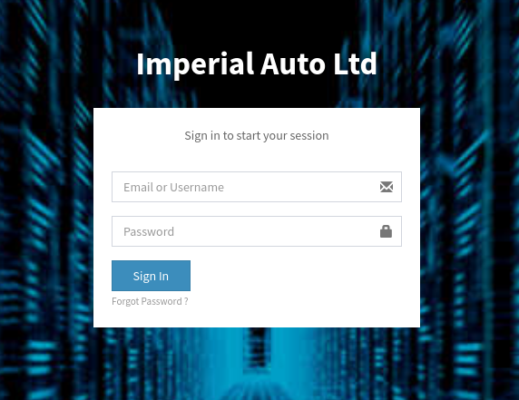
To be able to access the application, the user must enter his/her email and password.

Forgot Password
It may happen that a user forgets his / her password. What to do?
There are 2 ways to have your password changed.
1-The easiest way is from the login screen:
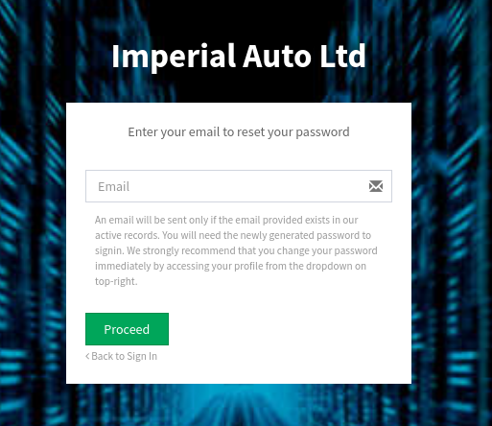
Simply click on Forgot Password on the sign in page, enter your registered email address. An email will be sent with a link which must be clicked for the password to be reset.

2-The second way is to ask an administrator to make the change for you. This can be made by editing the user and enter the new password in the password management section:
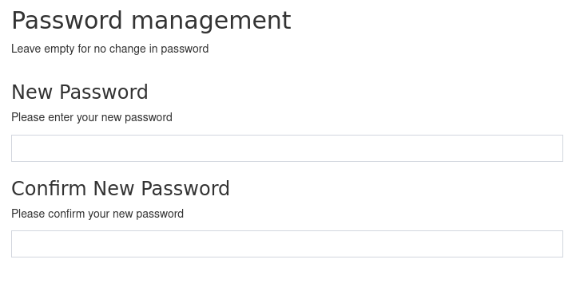

Add User
Admins have the permissions to add a new user.
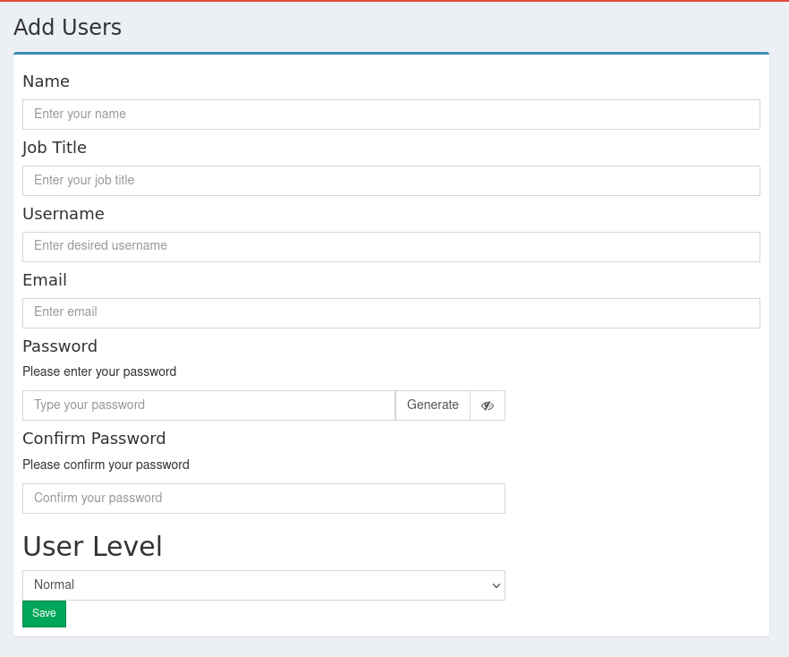
Name and Job Title are only for display purposes. Username and Email is unique in the system, which means that an email or a username cannot be used in more than one account.
User Level determines the set of permissions that are available for the user.
After a user has been added into the system he/she have no permissions to access any resource until permissions have been granted (see next section)

Permissions
As mentioned in the previous section, after a user has been added, permissions must be granted before they can access any resource. Also, users permissions can be updated when needed.
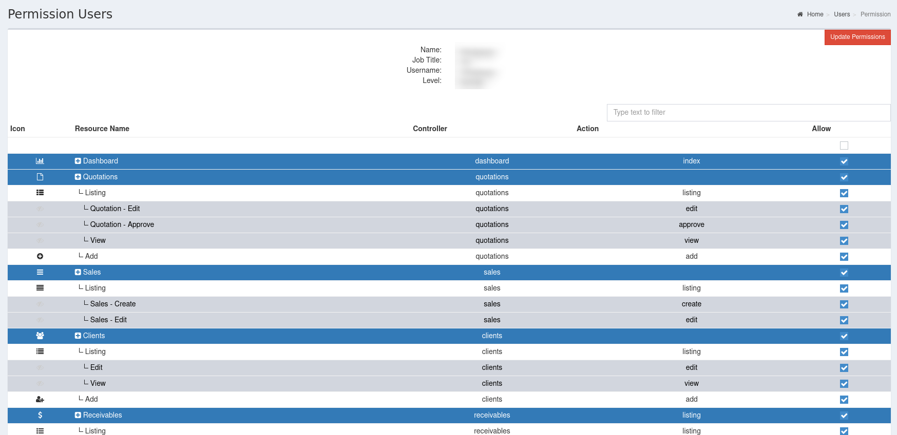
The permissions page shows a list of resources that the selected user have the possibility to access, based on his/her user level.

Vehicles
Vehicles can be added into the system at a very early stage, when purchasing at auctions for example. In this case the status 'Coming Soon' will be attributed to it, with all the necessary details and photos.

Adding
To add a new vehicle into the system, navigate in left menu to Vehicles>Add, then enter all the details required and click on save.
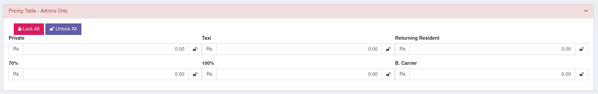
The above screenshot shows the pricing table which be used for creating quotations and hence sales.
Listing
The above screenshot shows a listing of vehicles recorded in the system, from where you edit or delete any of them.
The status of the vehicle can be changed by editing it, but there is also a quick way of doing it: changing the value in the drop down in the status column:
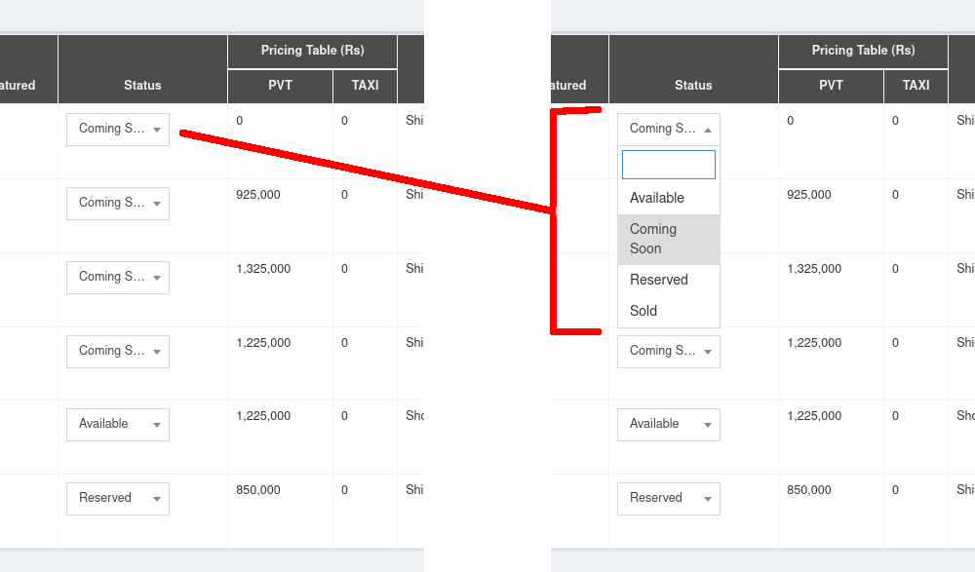

Quotation

Leasing
A financial institution can be added to a quotation. A button will be available after a quotation has been approved and balance is still greater than zero.
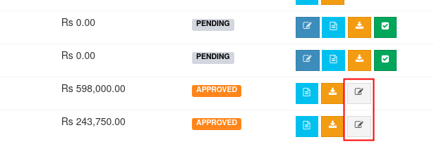
Click on the grey edit icon to add the name of the financial institution which then be used in various documents like deed of sale, pro-format invoice and others.
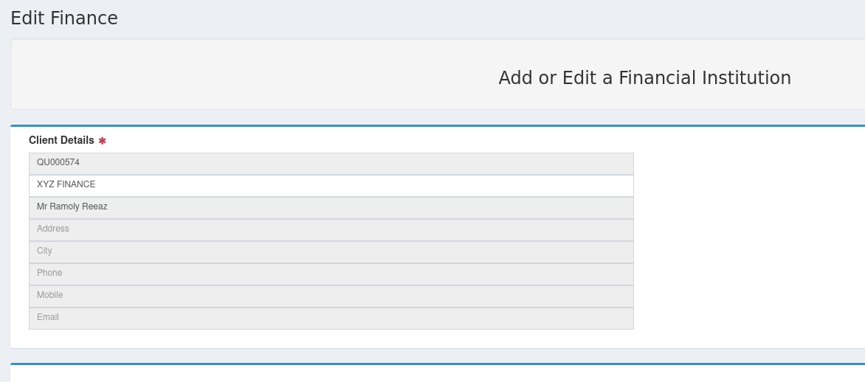

Sales & Payments
To convert a quotation into a sales, click on green icon from quotations listing, where you will be required to enter a payment.
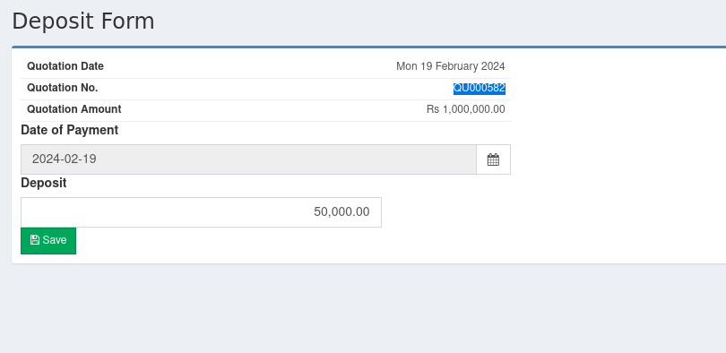
Once saved a new sales will be created and it will be visible in Sales > Listing
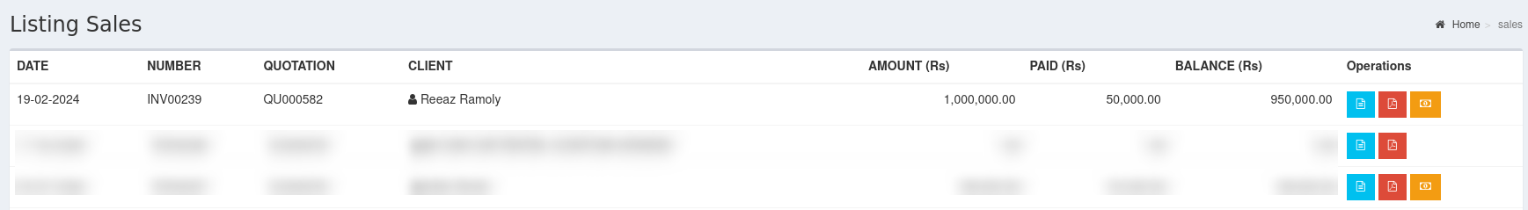
Subsequent payments can be entered by clicking on the yellow icon
A list of previous payment for this sale is shown just above the new payment entry.
